SUPERVISED LEARNING EVENT

CHEMICAL PATHOLOGY

Case-based Discussion
(CbD)

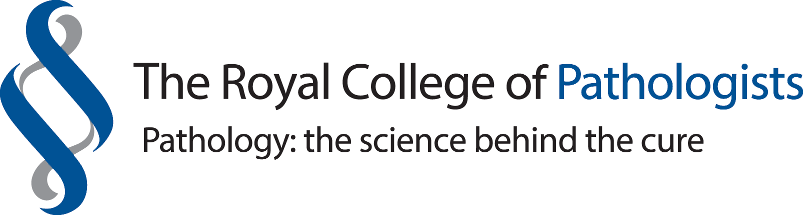

The Royal College of Pathologists

Pathology: the science behind the cure
Trainee’s name: |  |  | Year of training:  ST5 ST6 ST7

Assessor’s name: |  |  | Please circle one | Consultant Senior BMS SAS  Clinical scientist Senior Trainee Other

Brief focus for assessment

Please note constructive feedback is required in order for this assessment to be valid. Please comment on the assessment as appropriate – noting what was done particularly well, areas for improvement and any issues of patient safety. Do also aim to identify areas for learning and reflection.

Learning outcomes for discussion

What was done well?

What could be done differently?

Next steps

Signature of assessor: |  |  | Signature of trainee:

